1. Write a query to find the addresses (location_id, street_address, city, state_province, country_name) of all the departments.    
   Hint : Use NATURAL JOIN

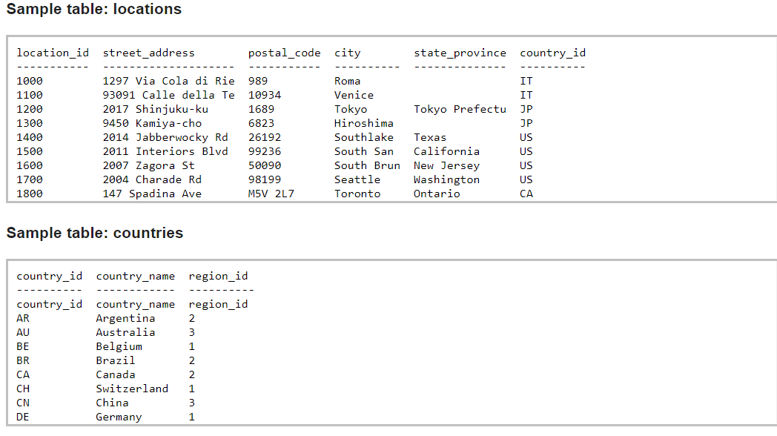

**Code:**

insert into countries

values ('AR', 'Argentina', '2');

insert into countries

values ( 'AU' , 'Australia', '3'),

('BE' , 'Belgium', '1'),

( 'BR' , 'Brazil', '2'),

('CA' , 'Canada', '2'),

('CH' , 'switzerland', '1'),

('CN' , 'China' , '3'),

('DE', 'Germany' , '1');

use learning;

Create Table locations (

location_id int(255) not null,

street_address varchar(255) not null,

postal_code varchar(255) not null,

city varchar(255) not null,

state_province varchar(255),

country_id varchar(255) not null

);

select * from locations;

insert into locations

values ('1000', '1297 Via Cola di Rie', '989', 'Roma','','it');

insert into locations

values ('1100', '93091 Calle della Te', '10934', 'Venice','','IT'),

('1200', '2017 Shinjuku-ku','1689', 'Tokyo','Tokyo Prefectu','JP'),

('1300', '9450 Kamiya-cho', '6823','Hiroshima','','JP'),

('1400', '2014 Jabberwocky Rd', '26192','Southlake','Texas', 'US'),

('1500','2011 Interiors Blvd', '99236','South San', 'California','US'),

('1600','2007 Zagora St', '50090', 'South Brun', ' New Jersey','US'),

('1700','2004 Charade Rd', '98199', 'Seattle','Washington','US'),

('1800','147 Spadina Ave', 'M5V 2L7', 'Toronto', 'Ontario', 'CA');

select l.location_id,l.street_address,l.city,l.state_province,countries.Country_Name

from locations as l

inner join countries on l.country_id=countries.Country_id;

**Output:**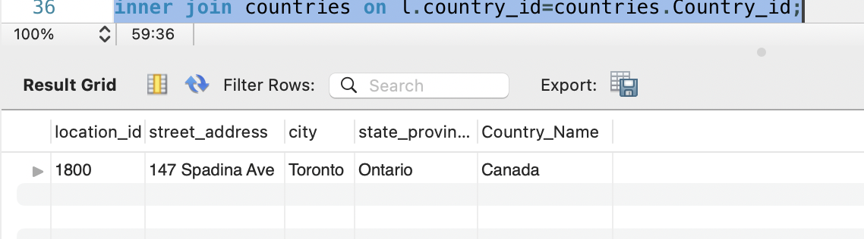

1. **2.** Write a query to find the name (first_name, last name), department ID and name of all the employees.

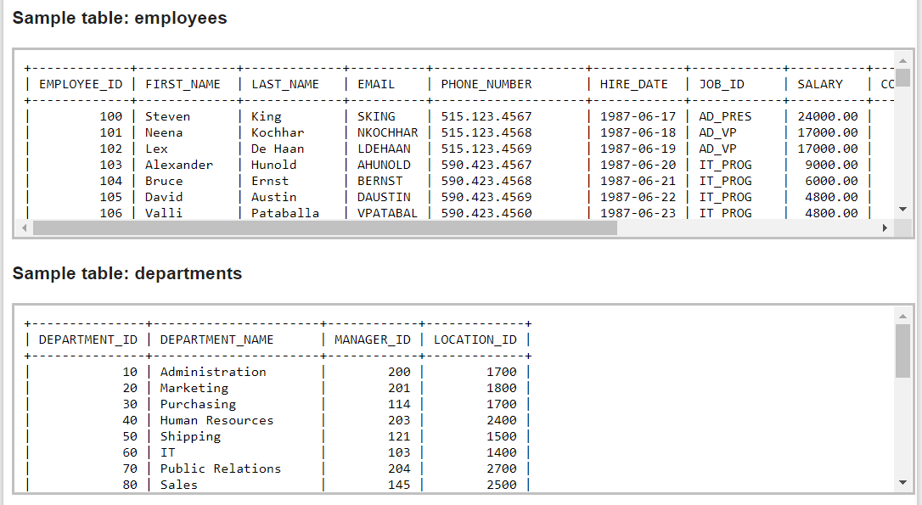

**Code:**

SELECT * FROM Learning.employee;

rename table employee to employees;

alter table employees

Modify phone_number Varchar(255);

alter table employees

Modify salary decimal (60,2);

insert into employees

values ('100','Steven','King','sking','515.123.4567', '1987-06-17','10','2400','','200','');

insert into employees

values ('101','Neena','Kochhar','nkochhar','515.123.4568','1987-06-18','10','17000','','200','');

insert into employees

values ('102','Lex','De Haan', 'LDEHAAN','515.123.4569','1987-06-19','10','17000','','200','');

insert into employees

values ('103','Alexander','Hunold','AHUNOLD','590.423.4567','1987-06-20','60','9000','','103',''),

('104','Bruce','Ernst','BERNST','590.423.4568','1987-06-21','60','6000','','103',''),

('105','David','Austin','DAUSTIN','590.423.4569','1987-06-22','60','4800','','103',''),

('106','Valli', 'Pataballa','VPATABAL','590.423.4560','1987-06-23','60','4800','','103','');

create table Departments (

DEPARTMENT_ID INT NOT NULL,

DEPARTMENT_NAME VARCHAR(255)NOT NULL,

MANAGER_ID INT NOT NULL,

LOCATION_ID INT,

UNIQUE (DEPARTMENT_ID)

);

INSERT into departments

values ('10','Administration','200','1700'),

('20','Marketing','201','1800'),

('30','Purchasing','114','1700'),

('40','Human Resources','203','2400'),

('50','shipping','121','1500'),

('60','IT','103','1400'),

('70','Public Relations', '204','2700'),

('80','Sales','145','2500');

select concat(first_name," ",last_name) as Name, departments.DEPARTMENT_ID

from employees

inner join departments on employees.Manager_id=departments.MANAGER_ID;

**Output:**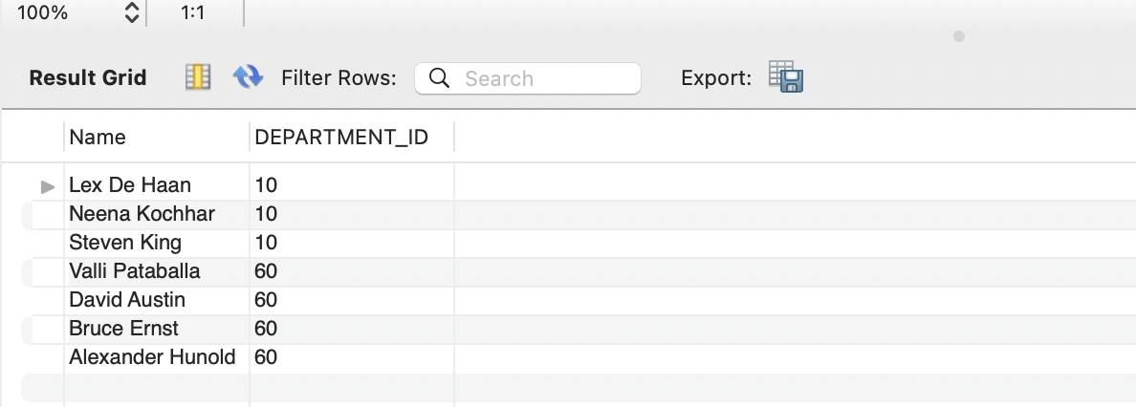

1. **3.** Write a query to find the name (first_name, last_name), job, department ID and name of the employees who works in London.

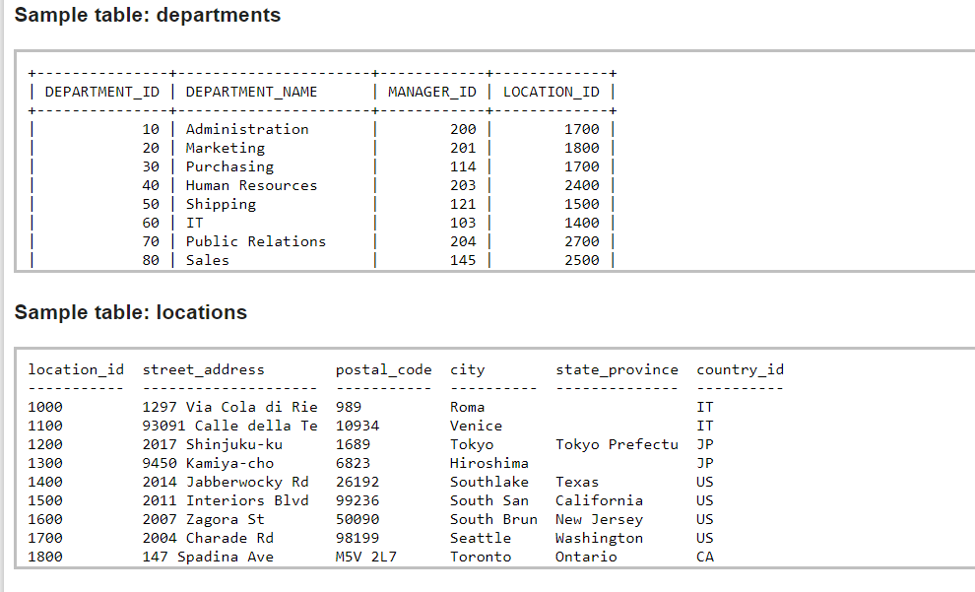

**Note:** since no London in the created table and only ‘country_id = US’ is common with “employees, Departments and Locations” tables which were not available in the “countries” table. Added value (US, America, 5) in Countries table and checked from America works.

**Code:**

Create Temporary table combine

select concat (first_name," ",last_name) as name, employees.job_id, Departments.Department_ID, Departments.LOCATION_ID,locations.country_id, countries.Country_Name

from employees, Departments, locations, countries

where employees.Manager_id = Departments.MANAGER_id and Departments.LOCATION_ID=locations.location_id and countries.Country_id=locations.country_id;

select * from combine;

insert into countries value ( 'US', 'America', '5');

Select Name, job_id, Department_id, Country_name

from combine

where Country_name=‘America';

**Output:**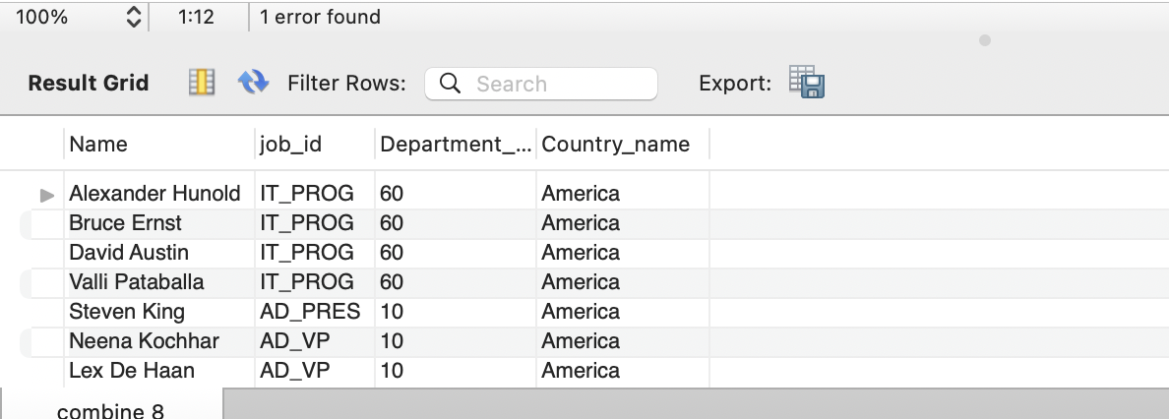

1. **1.** Write a query to find the name (first_name, last_name) and the salary of the employees who have a higher salary than the employee whose last_name='Bull'.

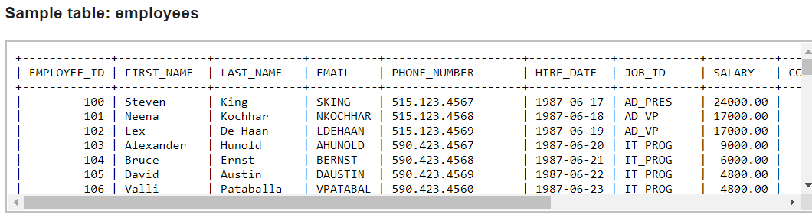

**Note**: last_name = ‘Bull’ is not available in the table employees, so checked for ‘Ernst’

**Code:**

select concat (first_name," ",last_name) as name,salary

from employees

where salary> any (select salary from employees where last_name =‘Ernst');

**Output:**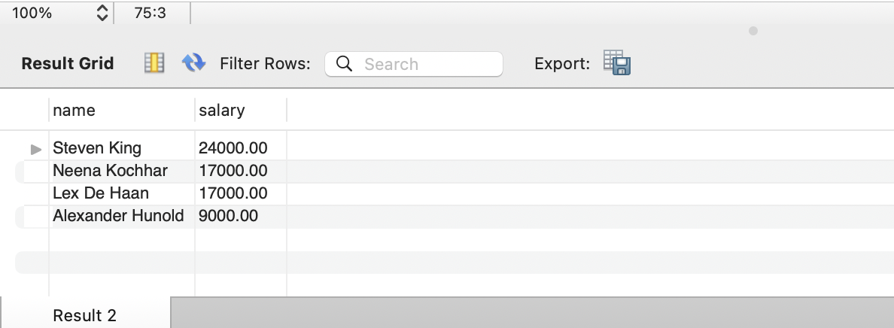

5. Write a query to find the name (first_name, last_name) of the employees who have a manager and worked in a USA based department.

Hint : Write single-row and multiple-row subqueries

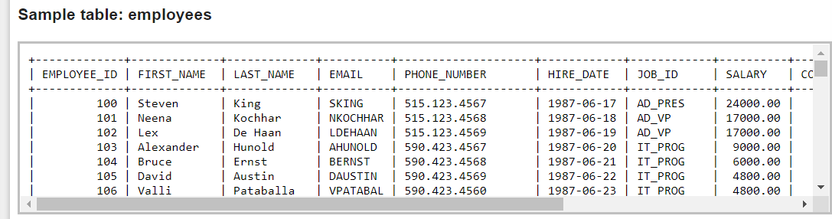

**Code:**

select concat (first_name, " ", last_name) as Name, locations.country_id

from employees,locations, Departments

Where locations.country_id='US' and locations.location_id=Departments.LOCATION_ID and employees.Manager_id=Departments.MANAGER_ID;

**Output:**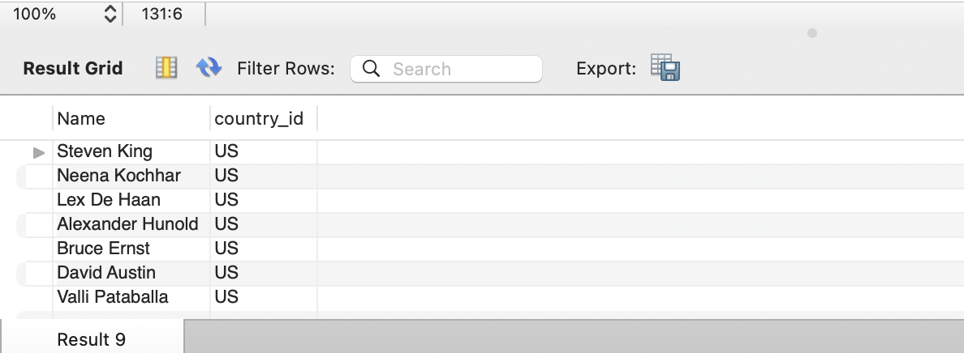

6.

Write a query to find the name (first_name, last_name) of the employees who are managers.

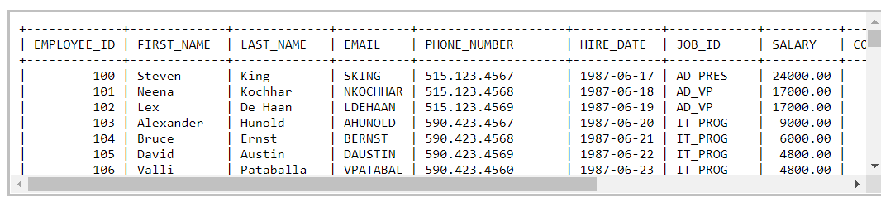

**Code:**

Select concat (first_name," ", last_name) as Name, employee_id

from employees,Departments

where employees.employee_id=Departments.MANAGER_ID;

**Output:**